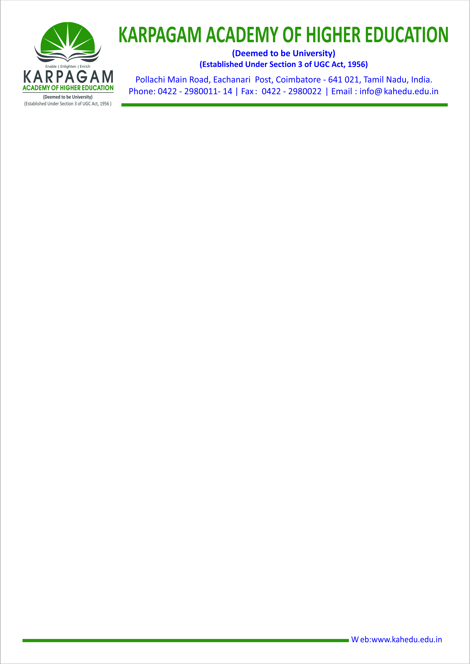

**Number of awards/medals won by students for outstanding performance in sports/cultural activities at Interuniversity/state/National/International events**

|  |  |  |
| --- | --- | --- |
| **Sl No** | **Year** | **No of Awards /Medals** |
| **1** | **2019-20** | [**61**](https://kahedu.edu.in/naac/C-5/Additional%20%20documents/5.3.1/19.pdf) |
| **2** | **2018-19** | [**93**](https://kahedu.edu.in/naac/C-5/Additional%20%20documents/5.3.1/18.pdf) |
| **3** | **2017-18** | [**19**](https://kahedu.edu.in/naac/C-5/Additional%20%20documents/5.3.1/17.pdf) |
| **4** | **2016-17** | [**18**](https://kahedu.edu.in/naac/C-5/Additional%20%20documents/5.3.1/16.pdf) |
| **5** | **2015-16** | [**21**](https://kahedu.edu.in/naac/C-5/Additional%20%20documents/5.3.1/15.pdf) |