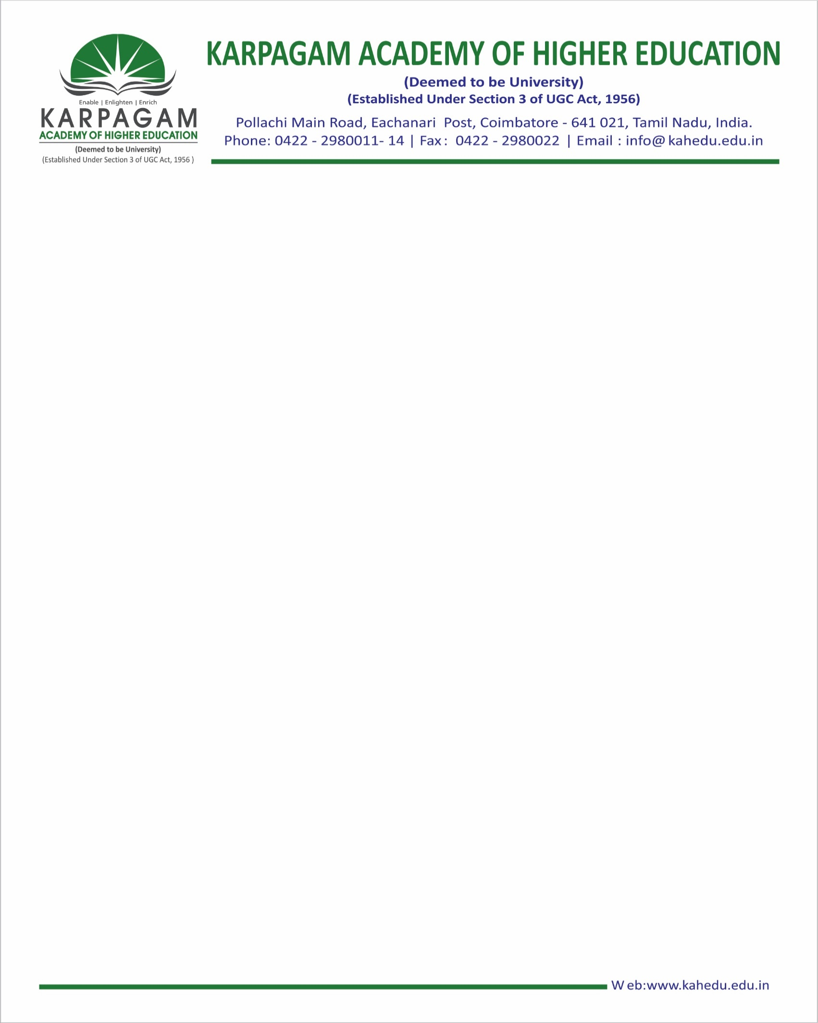

**Average number of sports and cultural events / competitions organised by the Institution per year**

|  |  |  |
| --- | --- | --- |
| **Sl No** | **Year** | **No of Events** |
| **1** | **2019-20** | [**49**](https://kahedu.edu.in/naac/C-5/Additional%20%20documents/5.3.3/19.pdf) |
| **2** | **2018-19** | [**49**](https://kahedu.edu.in/naac/C-5/Additional%20%20documents/5.3.3/18.pdf) |
| **3** | **2017-18** | [**41**](https://kahedu.edu.in/naac/C-5/Additional%20%20documents/5.3.3/17.pdf) |
| **4** | **2016-17** | [**41**](https://kahedu.edu.in/naac/C-5/Additional%20%20documents/5.3.3/16.pdf) |
| **5** | **2015-16** | [**42**](https://kahedu.edu.in/naac/C-5/Additional%20%20documents/5.3.3/15.pdf) |