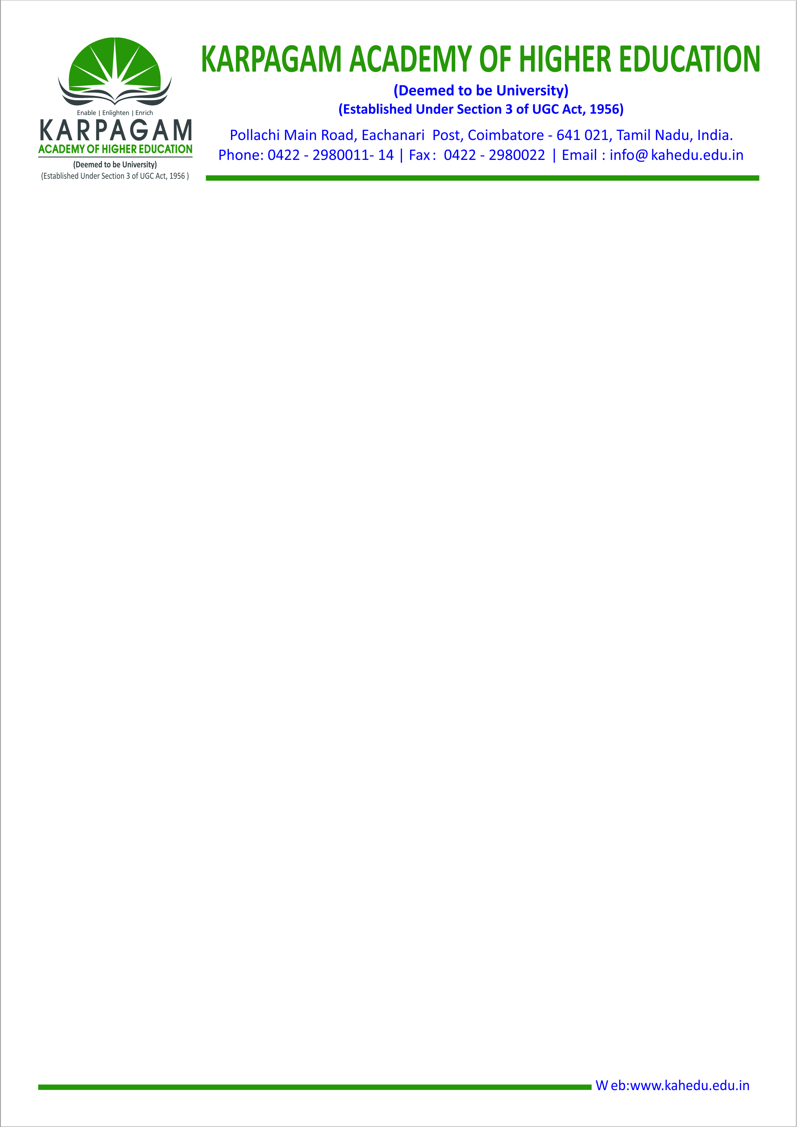

DVV Metric ID: 2.5.1

|  |  |  |  |
| --- | --- | --- | --- |
| **Sl. No.** | **Particulars** | **Page Numbers** | **Link** |
| 1 | Report from Controller of Examination for the academic year 2018-19. | 1 – 4 |  |
| 2 | Notified exam date and result declaration for five years. | 5 - 14 |
| 3 | Circulars from the Controller of Examination regarding Time Table for Semester Examination. | 15 - 25 |