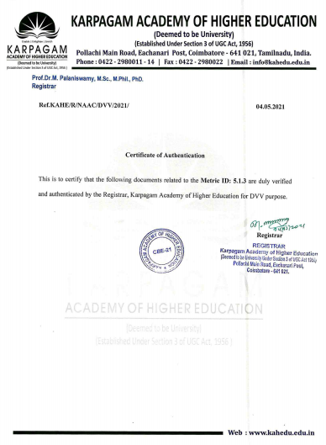



**5.1.3 Following Capacity development and skills enhancement initiatives are taken by the Institution**

1. **Soft skills 2.Language and communication skills**

**3.Life skills (Yoga, physical fitness, health and hygiene),**

**4.Awareness of trends in technology**

|  |  |  |
| --- | --- | --- |
| **Sl No** | **Name of the capability enhancement program** | **Link** |
| **1** | **Soft skills** | **S(2015-16)** |
| **S(2016-17)** |
| **S(2017-18)** |
| **S(2018-19)** |
| **S(2019-20)** |
| **2** | **Language and communication skills** | **LCS** |
| **3** | **Life skills (Yoga, physical fitness, health and hygiene)** | **LS** |
| **4** | **Awareness of trends in technology** | **A(2015-16)** |
| **A(2016-17)** |
| **A(2017-18)** |
| **A(2018-19)** |
| **A(2019-20)** |