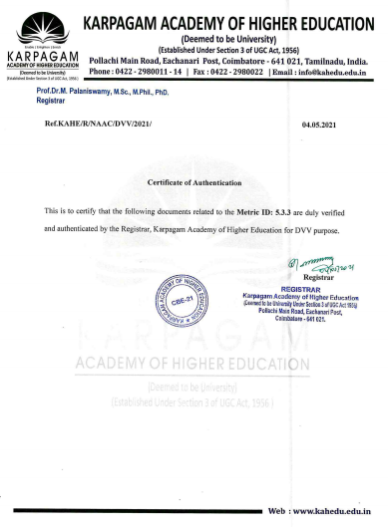



**5.3.3 Sports and cultural events / competitions**

|  |  |  |
| --- | --- | --- |
| **Sl No** | **Year** | **Link** |
| **1** | **2015-16** | **5.3.3(2015-16)** |
| **2** | **2016-17** | **5.3.3(2016-17)** |
| **3** | **2017-18** | **5.3.3(2017-18)** |
| **4** | **2018-19** | **5.3.3(2018-19)** |
| **5** | **2019-20** | **5.3.3(2019-20)** |