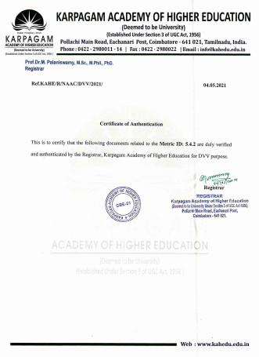



**5.4.2 - Alumni contribution during the last five years**

**(INR in lakhs) and List of Alumni -Quantam of**

**Contribution (year wise)**

**-**

**5.4.2 - Alumni Audited statement( Year wise)**

**(2019-20 - Page No.3, 2018-19 - Page No.13,**

**2017-18- Page No.21, 2016-17 - Page No.31,**

**2015-16 - Page No.39.)**

**5.4.2 - Alumni Audited statement(Additional Documents)**