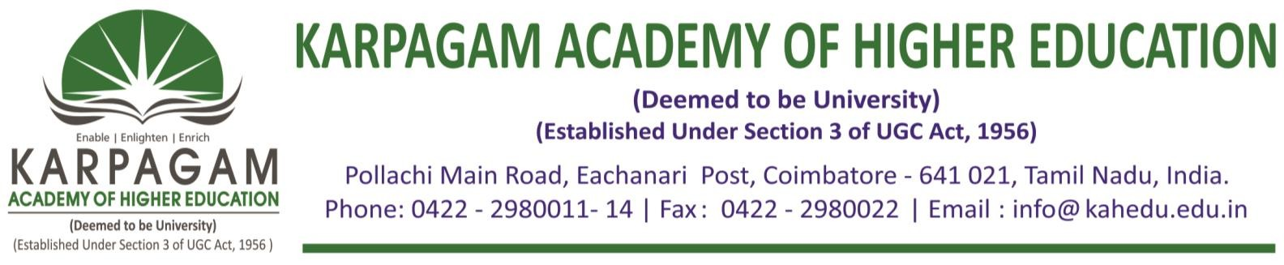

**6.3.3. The Brochures, Reports with Photographs and List of Participants of the following Professional Development/ Administrative Training Programs for the year 2016-2017 as follows**

|  |  |
| --- | --- |
| **S. No.** | **Title of the Professional Development/Administrative Training Programmes** |
| 1 | Professional Development Program on Research Method and Quality Research |
| 2 | Short Term Course on Cloud Computing and its services |
| 3 | Short Term Course on Estimation and Quantity Surveying |
| 4 | Short Term Training Program on CAD/CAM |

