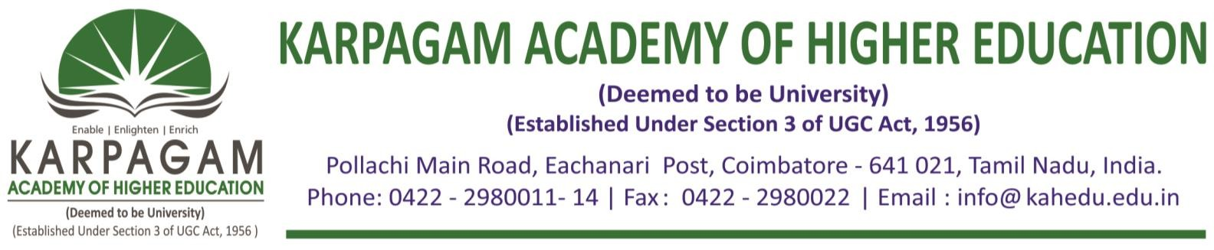

**6.3.3. The Brochures, Reports with Photographs and List of Participants of the following Professional Development/ Administrative Training Programs for the year 2017-2018 as follows**

|  |  |
| --- | --- |
| **S. No.** | **Title of the Professional Development/Administrative Training Programmes** |
| 1 | Professional Development Programme on Crystal Growth Techniques and Non Linear Optics |
| 2 | Short Term Course on Drug, Disease and Therapy: A Recent Advancement |
| 3 | Short Term Course on Drug Design |
| 4 | Professional Development Programme on Emerging Trends in Civil Engineering |
| 5 | Short Term Training Program on Non Destructive Testing |
| 6 | Professional Development Program on the Use of Contemporary Tools on Financial Research |
| 7 | Short Term Course on Mobile Application Development Using Kotlin |

