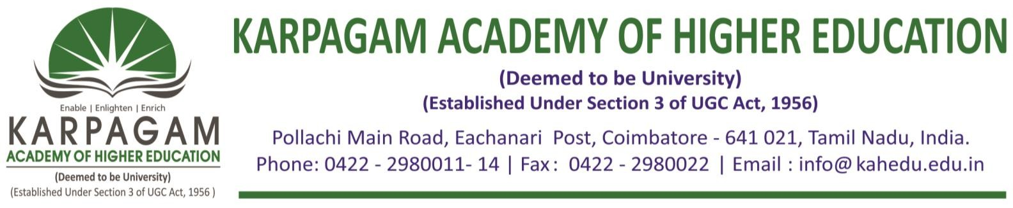

**6.3.3. The Brochures, Reports with Photographs and List of Participants of the following Professional Development/ Administrative Training Programs for the year 2019-2020 as follows**

|  |  |
| --- | --- |
| **S. No.** | **Title of the Professional Development/Administrative Training Programmes** |
| 1 | One Week STTP on Machine Learning and its Applications |
| 2 | Seven Days Professional Development Programme on Statistical Thermodynamics |
| 3 | Professional Development Programme on Research Methods and SPSS |
| 4 | Short Term Course on Material Testing and Evaluation |
| 5 | Professional Development Program on Artificial Intelligence and its Applications |
| 6 | Short Term Course on Case Study Analysis |

