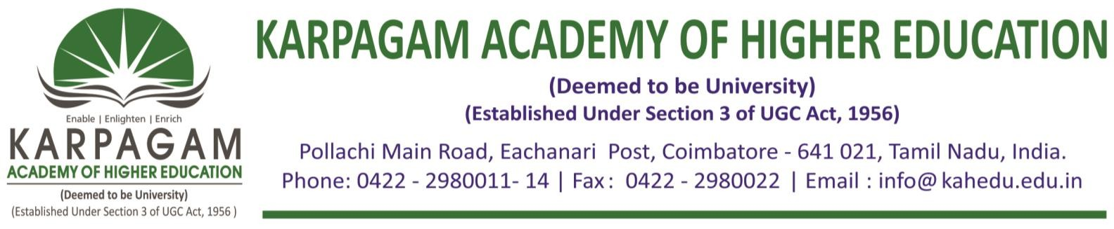

**6.3.4.**. **E-copy of the certificates of the program attended by teachers for the year 2015-2016**

|  |  |  |
| --- | --- | --- |
| **S. No.** | **Name of Teachers** | **Title of the Program** |
| 1 | Ms. A.Geethalakshmi | Professional Development Programme on IndirectTaxation |
| 2 | Mr. S. Sambath Kumar | Faculty Development Program on TallyERP-9 |
| 3 | Ms. D.Lavanya | Professional Development Programme on IndirectTaxation |
| 4 | Mr. V.MathanKumar | Professional Development Programme on IndirectTaxation |
| 5 | Ms. N. Ramyaprabha | Professional Development Programme on IndirectTaxation |
| 6 | Ms. C.V. Umamaheswari | Faculty Development Program on TallyERP-9 |
| 7 | Ms. R. JudithPriya | Professional Development Programmeon ResearchMethodology |
| 8 | Ms.P. Sopna | Professional Development Programme on Research Methodology |
| 9 | Mr. S. Karthik | Professional Development Programme on Research Methodology |

