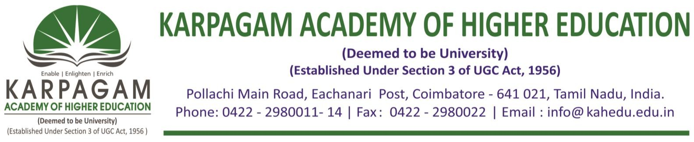

**6.3.4. E-copy of the certificates of the program attended by teachers for the year 2016-2017**

|  |  |  |
| --- | --- | --- |
| **S. No.** | **Name of Teachers** | **Title of the Program** |
| 1 | Ms. P. Sundaravalli | ShortTermCourse on e-Marketing |
| 2 | Ms. N. Sumathi | ShortTermCourse on e-Marketing |
| 3 | Ms. W.Saranya | ShortTermCourse on e-Marketing |
| 4 | Dr. S. Hemalatha | ShortTermCourse on e-Marketing |
| 5 | Ms. K. Gomathi | ShortTermCourse on e-Marketing |
| 6 | Dr. R. Velmurugan | ShortTermCourse on e-Marketing |
| 7 | Ms. K. Kavitha | ShortTermCourse on e-Marketing |
| 8 | Ms. Deepu Nair | ShortTermCourse on e-Marketing |
| 9 | Dr. K. Jothi | ShortTermCourse on e-Marketing |
| 10 | Ms. P. Kalaivani | ShortTermCourse on e-Marketing |

