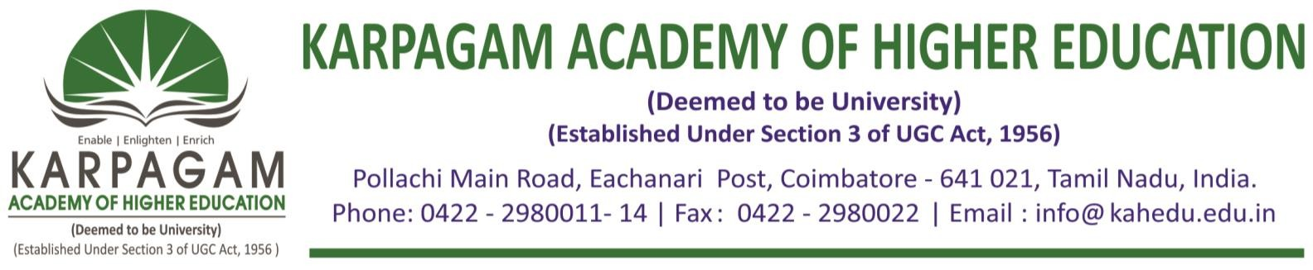

**6.3.4. E-copy of the certificates of the program attended by teachers for the year 2017-2018**

|  |  |  |
| --- | --- | --- |
| **S. No.** | **Name of Teachers** | **Title of the Program** |
| 1 | Dr.M.Deivanayaki | Professional Development Programme on DataAnalytics and Machine Learning |
| 2 | Dr. M. Rajeswari | Professional Development Programme on DataAnalytics and Machine Learning |
| 3 | Ms. B. Deepa | Professional Development Programme on DataAnalytics and Machine Learning |
| 4 | Mr. B. Arun | Professional Development Programme on DataAnalytics and Machine Learning |
| 5 | Ms. V. Vijayalakshmi | Professional Development Programme on DataAnalytics and Machine Learning |
| 6 | Dr. A. Arunkumar | Professional Development Programme on DataAnalytics and Machine Learning |
| 7 | Ms. R. Jagatheeshwari | Professional Development Programme on DataAnalytics and Machine Learning |

