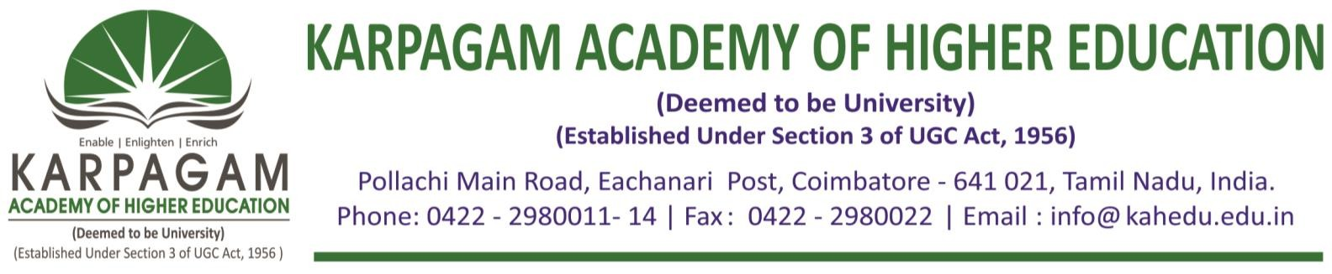

**6.3.4. E-copy of the certificates of the program attended by teachers for the year 2018-2019**

|  |  |  |
| --- | --- | --- |
| **S. No.** | **Name of Teachers** | **Title of the Program** |
| 1 | Ar. P. ArunPrasath | Faculty Development Programme |
| 2 | Dr. Paul Varghese | Faculty Development Programme |
| 3 | Ar. RishabYogesh Sharma | Faculty Development Programme |
| 4 | Ar. V. Balakrishnaa | Faculty Development Programme |
| 5 | Ar. R. SakthimuruganRajentren | Faculty Development Programme |
| 6 | Ar.S. Siva Ram | Faculty Development Programme |
| 7 | Ar. R. Sankar | Faculty Development Programme |

