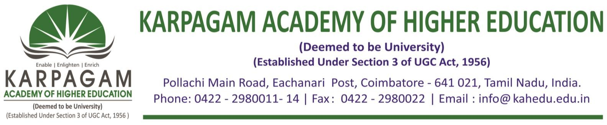

**6.3.4. E-copy of the certificates of the program attended by teachers for the year 2019-2020**

|  |  |  |
| --- | --- | --- |
| **S. No.** | **Name of Teachers** | **Title of the Program** |
| 1 | Mr. T.S.Bellraj | Professional Development Programme on Advancement in Biomedical Engineering |
| 2 | Mrs. Bhuvaneswari | 5 Day Faculty Development Program on Data Science and Big Data Analytics |
| 3 | Ms. S.Sree Sanjanaa Bose | 5 Day Faculty Development Programon Data Science and Big Data Analytics |
| 4 | Mr. T.Viswanathan | Professional Development Program on UNISIM Software Training |

